# Applying Filters to SQL Queries

## Project Description

This organization is trying to make their system more secure. In this project, I’m responsible for making sure the system is safe, investigating all potential security issues, and updating employee computers if needed. The following steps show how I used SQL with filters to accomplish these security tasks.

## Retrieving After Hours Failed Login Attempts

There was a potential after hours security incident and I need to investigate all failed login attempts after 18:00. The code in the following screenshot shows how I made a SQL query to filter for all the failed login attempts that happened after 18:00.

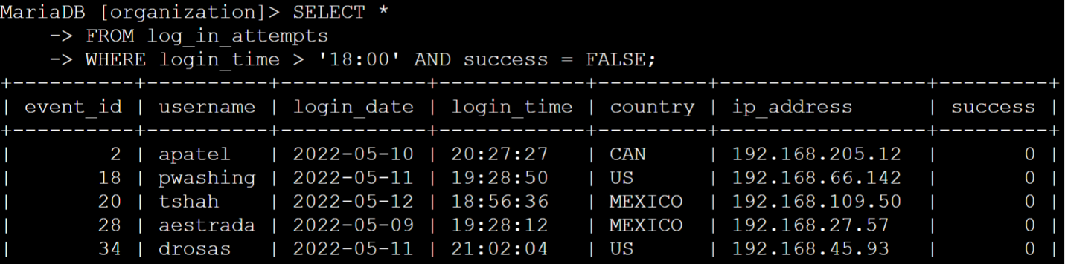

The first part of the screenshot shows the query I used, and the second part shows the results of that query. This specific query filters failed login attempts that occurred after 18:00. I first selected all the data from the log_in_attempts table. I them used a WHERE clause with an AND operator to filter the results to only output login attempts that happened after 18:00 and failed. The first condition is login_time > ’18:00’, which filters all login attempts that happened after 18:00. The second condition is success = FALSE, which filtered for all failed login attempts.

## Retrieve Login Attempts on Specific Dates

We know that a suspicious event happened on 2022-05-09, I need to investigate all login activity that happened on both 2022-05-09 and the day before, 2022-05-08. The screenshot below shows the code used to make a SQL query that filters for login attempts on these specific dates.

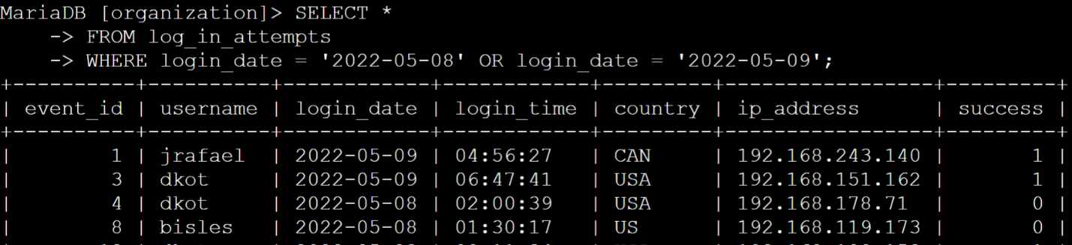

The first part of the screenshot is the query I used, and the second part is some of the output of that query. This query returned all login attempts that happened on both 2022-05-08 and 2022-05-09. I first selected all data from the log_in_attempts table. I then used a WHERE clause with an OR operator to filter the results to only show login attempts that happened on both 2022-05-08 and 2022-05-09. The first condition set is login_date = ‘2022-05-08’, and the second condition is login_date = ‘2022-05-09’. Both conditions filter the logins for each day.

## Retrieve Login Attempts Outside of Mexico

After I investigated the data on login attempts, I suspected that the login attempt issues happened outside of Mexico. All login attempts not in Mexico need to be investigated. The following screenshot shows the SQL query I made to filter all login attempts that happened outside of Mexico.

The first part of that screenshot shows the query I used, with the second part showing just a portion of the output. This query returned all login attempts that happened in all countries other than Mexico. I first selected all data from the log_in_attempts table. I then used a WHERE clause with NOT to filter for all other countries besides Mexico. I use LIKE with MEX% as the pattern match since the data displays Mexico as both MEX and MEXICO. The percentage sign (%) represents all unspecified characters when it is used with LIKE.

## Retrieve Employees in Marketing

Our team needs to update the computers of certain employees in the Marketing department, in order to do this I need to retrieve information on which employee computers need updating. The code below shows the SQL query I made to filter for employee computer from employees in the Marketing department, specifically in the East office.

The first part of the screenshot shows the query I made, and the second part shows just a portion of the output. This query returns all employees in the Marketing department who work in the East office. I first selected all data from the employees table. I then used a WHERE clause with AND to filter for the employees who work both in the Marketing department and the East office. I used LIKE with East% as the pattern to match since the data in the office column shows the East office with specific office numbers. The first condition I set is the department = ‘Marketing’ part, and the second condition I set is office LIKE ‘East%’. Both conditions filter the data to give us the Marketing employees in the East office.

## Retrieve Employees in Finance or Sales

Our team also needs to update the computers in the Finance and Sales departments. A different security update is needed, so I need to get information on employees only from these two departments. The following code shows the SQL query I made to filter for employee computers from employees in the Finance or Sales departments.

The first part of the screenshot shows the query I made, and the second part is just a portion of the output. This query returns all employees in both the Finance and Sales departments. I first selected all data from the employees table. I then used a WHERE clause with OR to filter for employees that are in the Finance or Sales departments. The OR operator is more useful than AND in the case since I want all employees in either department, not those in both. The first condition I set is department = ‘Finance’ and the second condition I set is department = ‘Sales’. Both conditions filter for employees in the Finance and Sales departments respectively.

## Retrieve All Employees Not in IT

Our team needs to make one more security update on employees who are not in the Information Technology department, to make this update I need to first get information on these employees. The screenshot below shows the SQL query used to filter for employee computers from employees not in the Information Technology department.

The first part of the screenshot shows the query I made, and the second part is just a portion of the output. I first selected all data from the employees table. The condition set is WHERE NOT department = ‘Information Technology’. The clause WHERE NOT allows me to exclude a specific department from the results. This condition filters for all employees who are not in the Information Technology department.

## Summary

This project allowed me to apply filters to SQL queries in order to get specific information regarding login attempts and employee computers. I utilized two different tables, log_in_attempts and employees to get the information needed. I then used the operators AND, OR, and NOT to filter for the specific information I needed for each task. I also used LIKE and the percentage sign (%) wildcard to filter for patterns in the data.